## Overview

* Name: Makeup API Dataset
* Source: Makeup API (http://makeupapi.herokuapp.com/)
* Purpose: This API provides data about various makeup products across different brands, categories, and types. It can be used for applications in e-commerce, beauty advice, product comparison, and more.
* Size: The size of the dataset is dynamic as it depends on the database's current state and the specific query made to the API.

## Content Description

* Variables/Columns: Typical data provided by the API includes:

`**id**`: Unique identifier for each makeup product.

`**brand**`: The brand of the makeup product.

`**name**`: The name of the makeup product.

`**price**`: The price of the product.

`price_sign`: Currency symbol for the price.

`currency`: The currency code for the price.

`**image_link**`: URL to an image of the product.

`**product_link**`: URL to the product page.

`**website_link**`: URL to the brand's website.

`**description**`: Text description of the product.

`**rating**`: Customer rating of the product.

`**category**`: Category of the makeup product (e.g., lipstick, foundation).

`**product_type**`: Specific type of product (e.g., lip liner, eyeliner).

* Data Types: The dataset includes a mix of string (text), numeric (for prices and ratings), and URL data types.
* Sample Data: To get sample data, one would typically make a GET request to one of the API's endpoints, such as `/api/v1/products.json`.

## Statistical Summary

Given that this is an API, the statistical summary (e.g., mean, median) would depend on the specific data retrieved and would have to be calculated based on the current dataset extracted from the API.

## Data Collection

* Methodology: The data is presumably collected from various product listings and catalogs from different makeup brands.
* Period & Frequency: Not specified, but the dataset is likely updated periodically to reflect new products, discontinuations, and changes in product details.

## Data Cleaning and Processing

* Preprocessing Steps: Specific preprocessing steps are not detailed, but the API likely involves normalization and cleaning to ensure data consistency and usability.

## Relationships and Constraints

* Relationships: Products are categorized by brand, category, and type, indicating a structured relationship within the dataset.
* Constraints: There might be limitations in terms of the completeness and availability of data for all products or brands.
* ERD:

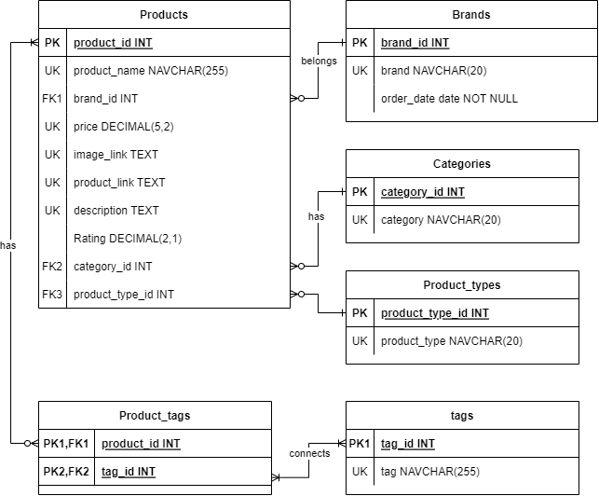

## Use Cases and Examples

* Applications: This API can be used to build applications that require detailed information about makeup products, such as comparison shopping tools, personal beauty recommendation systems, or inventory management systems for retailers.

## Accessibility

* Format: The data is accessible in JSON format via HTTP GET requests to the API's endpoints.
* Access: Publicly accessible through the API endpoints; no authentication details are mentioned, implying open access for basic requests.

## Legal and Ethical Considerations

* License & Privacy: There's no specific information on licensing or privacy considerations, but users should be cautious about how they use and display product images and descriptions, respecting copyright laws and any use restrictions.

## Citation

* Citing the Dataset: Since there's no direct guidance on citation, users should refer to the source as "Makeup API" with a link to the API's homepage in any publications or applications that use data from this API.